Industrial Facilities Design (Lab)
EF 431 L
LAB MANUAL
F2025

Program of BS Industrial Engineering
School of Engineering
University of Management and Technology, Lahore

Participant Name: ___________________________
Participant ID: ______________________________
Prepared by:(Name) | Munim Shaukat, 3 May 2021
Supervise by:(Name) | Tayyab Rabbani, 2 Feb 2021

IE 323L Course Learning Outcomes (CLOs)
On the completion of this course, student will be able to:
- Choose a suitable mathematical model for selection of location of a facility. (P3)
- Develop a factory layout using different material handling systems for discrete and continuous products and then simulate it. (P5)
- Follow the Lab Rules (A3)

Note: *P, A, C stand for psychomotor, affective, cognitive domains of Bloom’s taxonomy respectively. The numeric value refers to the corresponding level in each domain.For details regarding Bloom’s taxonomy, please see the annexure at the end of the manual.

Mapping of CLOs to Program Learning Outcomes (PLOs):
Semester | Course Code | Title | Course Learning Outcomes | PLO 1 Engg. Knowledge | PLO 2Problem Analysis | PLO 3Solution Design | PLO 4Investigation | PLO 5Mod. Tool Usage | PLO 6Engr. & Society | PLO 7Env. &Sust. | PLO 8Ethics | PLO 9 Team Work | PLO 10Communication | PLO 11Proj. Mgmt. | PLO 12Lifelong Learning
Seventh | EF 431 L | Industrial Facilities Design (Lab) | Choose a suitable mathematical model for selection of location of a facility.
 |  |  | Develop a factory layout using different material handling systems for discrete and continuous products and then simulate it.
 |  |  | Follow the Lab Rules

Grade Evaluation Criteria

Components | Marks
Lab Sessional (Quiz 10, Lab Performance 30) | 40
Open Ended Lab | 10
Final Performance | 25
Final Viva | 25
Total | 100



Exp. No | EXPERIMENTS |  | CLO
1 | Solve facility location selection problems by factor rating method by excel software. |  | 1, 2
2 | To Solve facility location selection problems by center of gravity method by excel software. |  | 1,2
3 | Identification of Optimal Facility Location Using Break-Even Analysis |  | 1,2
4 | To understand the GUI (graphical user interface) a flexSim and built a simple model using different objects. |  | 2,3
5 | Study and Evaluation of Industrial Facility Design of Mangla Dam |  | 2,3
6 | To build a model for purchasing three types of product and transport them using conveyors. |  | 2,3
7 | To build a model to use the operator and transporters for the material handling and explore the object properties in greater detail |  | 2,3
8 | To build a model to combine different in a pellet, through batch and joining. |  | 2,3
9 | To build a simple tugger train or locomotive movement by using AGV module. |  | 2,3
10 | To build a model for diversion of parts to different conveyors depending upon their different colors (Types). |  | 2,3
11 | To build a model with the fluid objects and analyze how they interact with each other and how to include them in a model with discrete objects. |  | 2,3
12 | To build a model in which one operator works on more than one machines. |  | 2,3
13 | To build a model for healthcare facility and Open-Ended Lab |  | 2,3
 | Final Exam

Lab Session No. 1
Solve facility location selection problems by factor rating method by excel software.
Software:
Excel software
Theory:
Factor Rating Method:
The concept of competency-based management has gone from a new technique to a common practice in the 35 years since David McClelland (1973) first proposed them as a critical factor of employees' performance.
It is most widely used analytical technique. it is most popular technique because a wide variety of factor can be included in the analysis. It is useful for service and industrial location. In this method to merge quantitative and qualitative factors, factors are assigned weights based on relative importance and weight age score for each site using a preference matrix is calculated. The site with the highest weighted score is selected as the best choice.

Steps of Factor Rating Method:
1. List relevant factors.
2. Assign importance weight to each factor.
3. Develop scale for each factor (0-1, etc.)
4. Score each location using factor scale.
5. Multiply scores by weights for each factor & total.
6. Select location with maximum total score.

Example 01:
The Dynaco Manufacturing Company is going to build a new plant to manufacture ring bearings (used in automobiles and trucks). The site selection team is evaluating three sites, and they have scored the important factors for each as follows. They want to use these ratings to compare locations.
Solution:
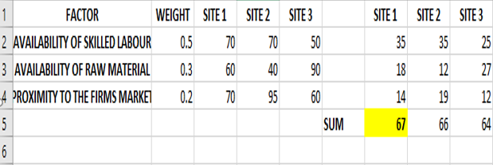
Example 02:
A company is going to decide where to build a new coffee roasting plant. The site selection team is evaluating three sites, and they have scored the important factors for each as follows. They want to use these ratings to compare locations. The locations are Dallas and Denver.
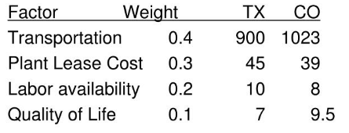

Solution:
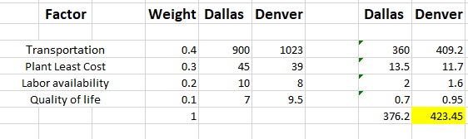
Comments:
We understand the method of factor rating. The sum of Weightage of all factors is always equal to 1. Multiply weight with rating factor of sites or name of sites. Then total and the highest number tell us the location. We solve it on excel software.

Procedure (On students’ own words)
______________________________________________________________________________________________________________________________________________________________________________________________________________________________________________________________________________________________________________________________________________________________________________________________________________________________________________________________________________________________________________________________________________________________________________________________________________________________________________________________________________________________________________________________________________________________________________________________________________________________________________________________________________________________________________________________________________________________________________________________________________________________________________________________________________________________________________________________________________________________________________________________________________________________________________________________________________________________________

Difficulties / Suggestions
______________________________________________________________________________________________________________________________________________________________________________________________________________________________________________________________________________________________________________________________________________________________________________________________________________________________________________________________________________
Concluding Remarks / Comments
____________________________________________________________________________________________________________________________________________________________________________________________________________________________________________________________________________________________________________________________________________________________________________________________________________

Lab Session No. 2
To Solve facility location selection problems by center of gravity method by excel software.

Software:
Excel software

Theory:

Center of Gravity Method:
In logistics, the Centre of Gravity analysis is a method of calculating the ideal location for a centralized distribution center. It makes it possible to optimize your supply chain. This method considers existing warehouse facilities and calculates the perfect location based on:
- Markets
- Volume of goods
- Shipping
- Transport costs
- M2 availability
- Labor market situation and cost
- Industry knowledge
You can calculate the center of gravity based on demand, supply, or the lowest distribution costs, depending on if you determine the best location from a service point (e.g. lead times) of view or a cost point of view.
The number of shipments and volume are essential weighing factors when calculating the Centre of Gravity from a cost perspective. If you calculate the Centre of Gravity from a service point of view, delivery times, for example, play an important role. Also, reducing co2 emissions can be a weighing factor.
Steps:

Step 1:
- Place existing warehouse, fulfillment center, and distribution center locations in a coordinate grid.
- Place the grid on an ordinary map.
- The relative distances must be noted.

Step 2:
Then, using the equations below,
- Cx= ∑ dix Vi/ ∑ Vi
- Cy= ∑ diy Vi/ ∑ Vi
We calculate the X and Y coordinates using these equations where Cx is the X (horizontal axis) coordinate for the new facility. Cy is the Y (vertical axis) coordinate for the new facility, dix is the X coordinate of the existing location, diy is the Y coordinate of the existing location, and Vi is the volume of goods moved to or from the ith location.

Step 3:
Once you have obtained the X and Y coordinates place that location on the map.
But, it doesn’t end there. As I mention earlier, there are other factors to consider. What this method allows is a point of departure – or, literally, a starting point of where (from the perspective of longitude and latitude) your options are for where to grow your fulfillment or logistics network.
Example 01:
A company wants to locate a new facility with in a network of three existing facilities. Given the following variables and grids, what are the coordinates of new location.
- Facility 1 has the daily goods volume of 2,500 units.
- Facility 2 has the daily goods volume of 1,300 units.
- Facility 3 has the daily goods volume of 5,000 units.
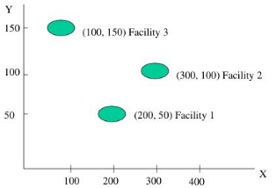
Solution:
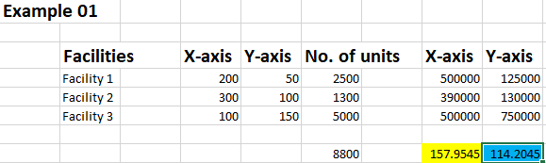
Example 02:
Several automobile showrooms are located according to the following grid which represents coordinate locations for each showroom.
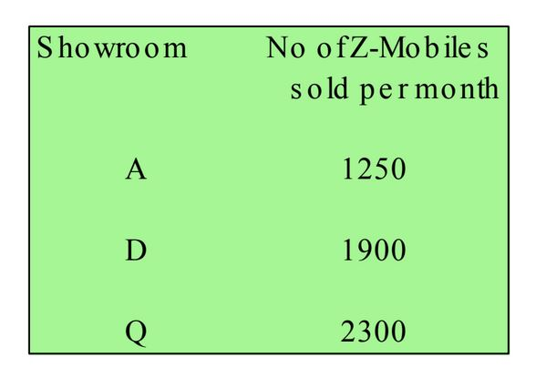
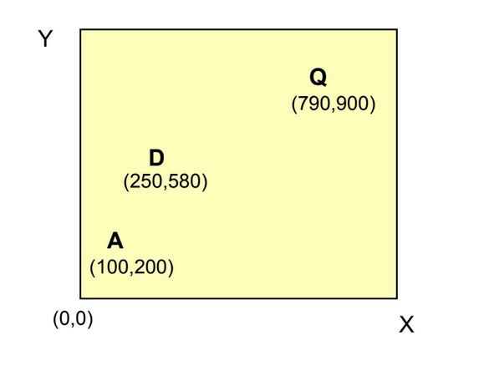
Solution:

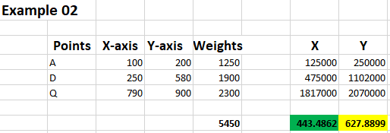

Comments:
If an organization wants to find the location of warehouse, then we use center of gravity method to find an optimal location of warehouse. There are different factors we consider when we find an optimal location for warehouse like markets, volume of goods, shipping, transport costs, labor market situation and cost and industry knowledge.

Procedure (On students’ own words)
______________________________________________________________________________________________________________________________________________________________________________________________________________________________________________________________________________________________________________________________________________________________________________________________________________________________________________________________________________________________________________________________________________________________________________________________________________________________________________________________________________________________________________________________________________________________________________________________________________________________________________________________________________________________________________________________________________________________________________________________________________________________________________________________________________________________________________________________________________________________________________________________________________________________________________________________________________________________________

Difficulties / Suggestions
______________________________________________________________________________________________________________________________________________________________________________________________________________________________________________________________________________________________________________________________________________________________________________________________________________________________________________________________________________
Concluding Remarks / Comments
__________________________________________________________________________________________________________________________________________________________________________________________________________________________________________________________________________________________________________________________________________

Questions:
- How would the Center of Gravity location change if transportation cost per unit distance is not uniform across all routes?
- Why might the Center of Gravity method give a mathematically optimal location that is practically infeasible?
- How does calculating the Center of Gravity from a service-level perspective differ from a cost-based perspective?
- In what situation would reducing CO₂ emissions alter the Center of Gravity result compared to a traditional cost-minimization approach?
(Provide Class work at the end of this Lab Activity)

Lab Session No. 3

Identification of Optimal Facility Location Using Break-Even Analysis Objective
To identify the most economical location for establishing a new facility by applying the Break-Even Analysis Method based on fixed and variable costs at different alternative locations.

Software / Tools
- Microsoft Excel / Google Sheets
(or manual calculations using calculator)

Theory
The Break-Even Method is a quantitative technique used in facility location decisions to compare multiple location alternatives based on their cost structures.
Each location has:
- Fixed Costs (F): Costs that do not vary with production or output (e.g., rent, machinery, administration).
- Variable Costs (V): Costs that vary per unit of output (e.g., labor, utilities, transportation).
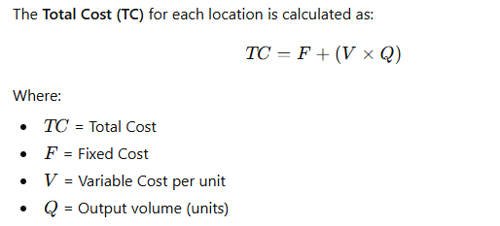
The location with the lowest total cost at a given output level is considered the optimal choice.

Problem Statement
A manufacturing company is considering three alternative locations (A, B, and C) for setting up a new facility. The estimated fixed and variable costs are given below:
Location | Fixed Cost (Rs./Year) | Variable Cost (Rs./Unit)
A | 2,000,000 | 180
B | 1,500,000 | 220
C | 1,000,000 | 260
The expected annual production volume is 10,000 units.

Procedure

Step 1:
List the fixed cost and variable cost for each location.

Step 2:
Use the total cost equation for each location:
TC=F+(V×Q)TC = F + (V \times Q)TC=F+(V×Q)

Step 3:
Calculate the total cost of each location at the given output level.

Step 4:
Plot Total Cost vs Output (Q) for all locations on a graph.

Step 5:
Identify the break-even point(s) where the cost lines intersect.

Step 6:
Select the location with the minimum total cost at the expected output level.

Calculations
For Q=10,000:
- Location A
TC_{A}=
- Location B
TC_{B} =
- Location C
TC_{C}=

Result
At an annual production level of 10,000 units, Location _____ is the most economical choice, as it has the lowest total cost among the three alternatives.

Conclusion
The Break-Even Analysis Method provides a clear and quantitative approach for facility location decisions by comparing cost structures. While Location C has higher variable cost, its lower fixed cost makes it economical at the given production level.

Procedure (On students’ own words)
______________________________________________________________________________________________________________________________________________________________________________________________________________________________________________________________________________________________________________________________________________________________________________________________________________________________________________________________________________________________________________________________________________________________________________________________________________________________________________________________________________________________________________________________________________________________________________________________________________________________________________________________________________________________________________________________________________________________________________________________________________________________________________________________________________________________________________________________________________________________________________________________________________________________________________________________________________________________________

Difficulties / Suggestions
______________________________________________________________________________________________________________________________________________________________________________________________________________________________________________________________________________________________________________________________________________________________________________________________________________________________________________________________________________
Concluding Remarks / Comments
____________________________________________________________________________________________________________________________________________________________________________________________________________________________________________________________________________________________________________________________________________________________________________________________________________

Questions
- Why is break-even analysis useful in facility location decisions?
- What happens if production volume increases significantly?
- Which cost component influences decisions at low output levels?
- State one limitation of the break-even method.

Lab Session No.4
To understand the GUI (graphical user interface) a flexSim and built a simple model using different objects.
Software:
FlexSim
Theory:
You will primarily build your simulation model using two interfaces: the 3D model and the Process Flow tool. The 3D model is where you will visualize your business system using 3D graphics. The Process Flow tool is where you will build the logic that powers your 3D model.
The most important elements of the 3D model interface are shown in the following image:
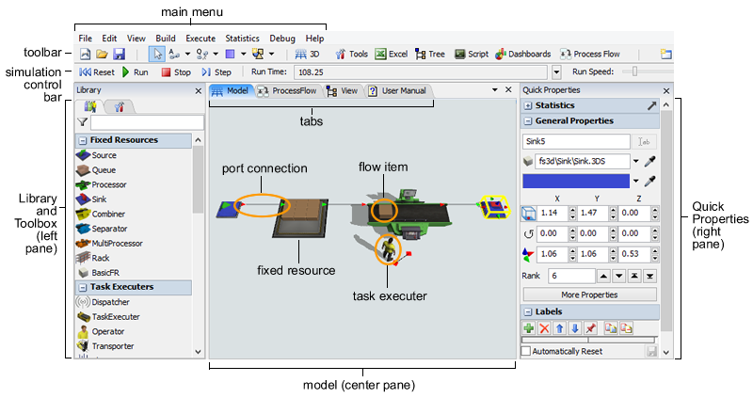
The Process Flow interface closely resembles the 3D model interface. The most important elements of the Process Flow tool are labeled in the following image:
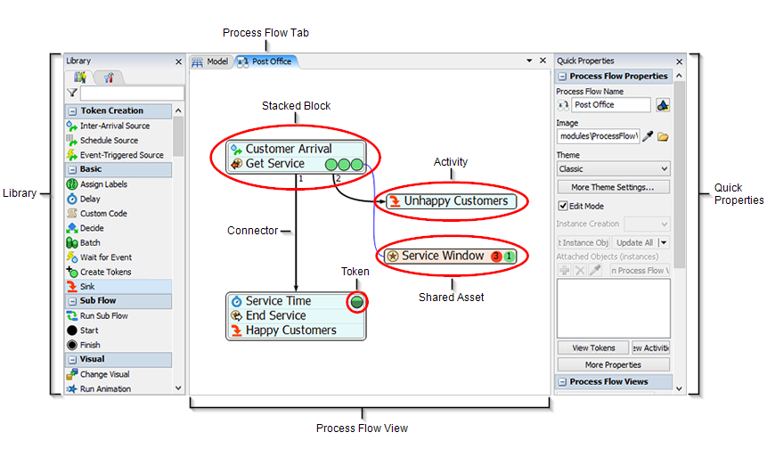
This topic will focus on explaining the elements of the 3D model interface.
3D Model (Center Pane):
Located in the center pane, the 3D model is the main workspace you will use to create a 3D simulation model of your business system. You can drag objects from the Library into the model to begin creating your simulation. When you run a simulation, the objects in your simulation model will begin to move and interact based on the logic you have defined in your simulation model.
Objects (Fixed Resources, Task Executers, Flow Items)
Objects are the basic building blocks of a 3D simulation model. Different types of objects have different purposes and functions within the simulation model. Some of the most common objects are:
- Flow Items:
Objects that move (or "flow") through the simulation model, usually from one station (typically a fixed resource) to another downstream station. Flow items can represent products, customers, paperwork, parts, or any other item that moves to various stations in your business system. By default, flow items look like boxes, but you can change the flow items to look like people (customers) or other shapes.
- Fixed Resources:
Objects that remain stationary in the 3D model. Each fixed resource performs a specific function. For example, a source creates flow items at specific intervals and introduces them to the model. A queue stores flow items until they are needed downstream. A sink removes flow items from the model, and so forth.

- Task Executers:
Objects that can move around in the 3D model and perform tasks such as transporting flow items, operating machines, etc. The most common type of task executer is the operator, which can represent an employee in the simulation model.
There are many types of objects besides the main ones mentioned here.
Library and Toolbox (Left Pane):
Located in the left pane, the Library contains a variety of objects that you can use to build your 3D simulation model. Each type of object has specific settings (properties) that you can customize. Sometimes the Library will display different objects based on the tool that is open and active in the center pane at the time. For example, when the Process Flow tool is open, the Library will display a set of objects (activities) that are unique to Process Flow.
The Library also shares the left pane with the Toolbox, which is where you will manage the tools you want to use in your simulation model (such as Process Flow, Dashboards, Global Tables, etc).
Quick Properties (Right Pane):
Located in the right pane, Quick Properties allows you to quickly edit the settings (properties) for any object that is currently selected in the model or in a given tool. You can also sometimes use the Quick Properties pane to view important information (such as statistics) about objects when they are selected during a simulation run.
Tabs:
When you open some of the tools in FlexSim, they might split or share the center pane with the simulation model. These tools each have their own tab in the center pane. You can click the tabs to make them active if needed. You can also control how FlexSim displays these tools or how they split the center pane.
Ports and Port Connections:
Objects in the simulation model need to be connected in some way in order to interact during a simulation model. One of the ways in which objects can be connected is through ports. There are two types of ports in FlexSim:
- Inputs / Outputs Port:
These ports determine how and when a flow item passes from one fixed resource to another. When an output port on one fixed resource is connected to the input port of another object downstream, the flow item will pass from the first object's output port to the next object's input port (unless that port is closed).
- Center Ports:
These ports determine how and when a flow item passes from one fixed resource to another. When an output port on one fixed resource is connected to the input port of another object downstream, the flow item will pass from the first object's output port to the next object's input port (unless that port is closed).
Main Menu:
The main menu contains all of the tools and commands you might use while building your simulation model.
Tool Bar:
The tool bar gives quick access to many of the commonly used tools and commands in FlexSim.
Simulation Control Bar:
The simulation control bar contains the tools and commands you will need to run your simulation.
Environments:
Located in the top right corner, the environments button lists available environments. Environments customize the look and feel of the program to better serve the needs of different kinds of users. For example, the Healthcare environment customizes the toolbar and reorders the library so that healthcare related tools and objects are more prominently displayed.
Creating new model:
You can create a new model two different ways in FlexSim:
When you first open FlexSim, you see the start screen. You can start a new model by clicking New Model on the left menu.
On the toolbar, click the new button to start a new model.
Using either method will open the Model Units dialog box where you can specify the measurement units for your model, as shown in the following image:

See the following section, About Model Units, for more information about the different model units. If you always want to use the default measurements when creating a new model in FlexSim, you can clear the show this window for each new model check box at the bottom of the Model Units dialog box.
After selecting the appropriate measurement units for your model, click the OK button to create your new simulation model.
Model:
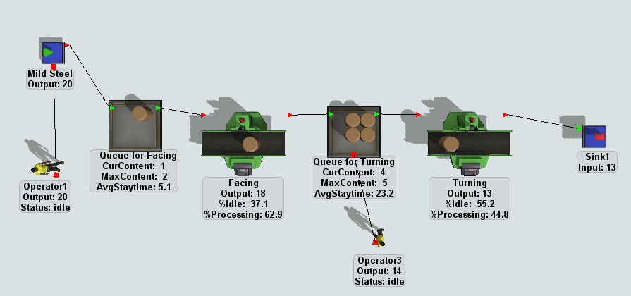
Comments:
In this lab we learn the user interface of FlexSim software, its objects and how to select a window for new model. We create a simple model in FlexSim.

Procedure (On students’ own words)
______________________________________________________________________________________________________________________________________________________________________________________________________________________________________________________________________________________________________________________________________________________________________________________________________________________________________________________________________________________________________________________________________________________________________________________________________________________________________________________________________________________________________________________________________________________________________________________________________________________________________________________________________________________________________________________________________________________________________________________________________________________________________________________________________________________________________________________________________________________________________________________________________________________________________________________________________________________________________

Difficulties / Suggestions
______________________________________________________________________________________________________________________________________________________________________________________________________________________________________________________________________________________________________________________________________________________________________________________________________________________________________________________________________________
Concluding Remarks / Comments
____________________________________________________________________________________________________________________________________________________________________________________________________________________________________________________________________________________________________________________________________________________________________________________________________________
Question
- How does the Process Flow (PFD) interact with 3D model objects in FlexSim, and why is this separation important?
- What happens in the model if object connections exist in the 3D view but logic is missing in the Process Flow?
- How does changing an object’s Properties Panel parameters during runtime affect simulation results?
- Why is the Tree View hierarchy critical when debugging complex FlexSim models?

Lab Session No. 5
Study and Evaluation of Industrial Facility Design of Mangla Dam

Objective
To analyze the layout, functional zoning, material flow, safety provisions, and utility integration of Mangla Dam as a large-scale industrial facility, using principles of Industrial Facility Design.

Location of Industrial Visit
Mangla Dam, Mirpur (AJK), Pakistan

Tools / Resources
- Site visit observations
- Facility layout drawings (if available)
- Camera / notebook
- Google Maps (for macro-layout understanding)

Theory
Industrial Facility Design involves planning and arranging physical facilities, such as buildings, equipment, utilities, and support services, to achieve efficient operations, safety, flexibility, and sustainability.
Mangla Dam is a multi-functional industrial facility, integrating:
- Power generation (hydropower plant)
- Water storage and control
- Spillway systems
- Control rooms and maintenance workshops
- Safety and security infrastructure
Key IFD concepts applicable:
- Process layout
- Functional zoning
- Material and energy flow
- Maintenance accessibility
- Safety and environmental considerations

Scope of the Experiment
This experiment focuses on evaluating Mangla Dam as an industrial facility, not merely as a civil structure.

Procedure

Step 1: Facility Identification
Identify the major functional areas of Mangla Dam, such as:
- Intake structure
- Powerhouse (turbine-generator hall)
- Control room
- Spillways
- Maintenance and workshop areas
- Administrative buildings
- Security and safety zones

Step 2: Layout Analysis
- Sketch or obtain a macro-level layout of the dam facility.
- Identify the type of layout used (process/functional layout).
- Explain why this layout is suitable for hydropower operations.

Step 3: Flow Analysis
- Analyze the flow of water (energy) from reservoir to turbines.
- Identify supporting flows such as:
  - Personnel movement
  - Maintenance equipment movement
  - Electrical power evacuation

Step 4: Safety and Risk Considerations
Observe and document:
- Emergency spillways
- Access control and security checkpoints
- Warning systems and signage
- Separation of hazardous and safe zones

Step 5: Utility and Support Services
Study the integration of:
- Electrical substations
- Cooling systems
- Drainage and water management
- Communication systems

Step 6: Environmental and Sustainability Aspects
Analyze:
- Flood control measures
- Environmental impact mitigation
- Efficient land use
- Noise and vibration control in powerhouse

Conclusion
The industrial tour of Mangla Dam provided practical insight into how Industrial Facility Design principles are applied in infrastructure-scale industrial systems, where efficiency, safety, and sustainability are critical.

Observation (On students’ own words)
______________________________________________________________________________________________________________________________________________________________________________________________________________________________________________________________________________________________________________________________________________________________________________________________________________________________________________________________________________________________________________________________________________________________________________________________________________________________________________________________________________________________________________________________________________________________________________________________________________________________________________________________________________________________________________________________________________________________________________________________________________________________________________________________________________________________________________________________________________________________________________________________________________________________________________________________________________________________________

Difficulties / Suggestions
______________________________________________________________________________________________________________________________________________________________________________________________________________________________________________________________________________________________________________________________________________________________________________________________________________________________________________________________________________
Concluding Remarks / Comments
____________________________________________________________________________________________________________________________________________________________________________________________________________________________________________________________________________________________________________________________________________________________________________________________________________

Questions
- Why is Mangla Dam considered an industrial facility rather than only a civil structure?
- What type of facility layout is used in hydropower plants and why?
- How is safety integrated into the facility design of Mangla Dam?
- Identify one facility design constraint unique to dam operations.

Lab Session No. 6
To build a model for purchasing three types of product and transport them using conveyors.
Software:
FlexSim
Theory:
The processor is used to simulate the processing of flow items in a model. The process is simply modeled as a forced time delay. The total time is split between a setup time and a process time. The processor can process more than one flow item at a time. Processors may call for operators during their setup and/or processing times. When a processor breaks down, all of the flow items that it is processing will be delayed.
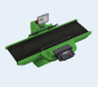
The processor is a fixed resource. It is also a super-class of the combiner and separator 3D objects. It continues to receive flow items until its maximum content is met. Each flow item that enters the processor goes through a setup time followed by a process time. After these two processes have finished, the flow item is released. If the maximum content value is greater than one, then flow items will be processed in parallel.
States:
For statistical purposes, the processor will be in one of the following states at various points during a simulation run. The current state can be viewed by clicking on the object and then viewing the Statistics pane in Quick Properties.
Idle:
The object is empty.
Setup:
The object is in its modeler-defined setup time.

Processing:
The object is in its modeler-defined process time.
Blocked:
The object has released its flow item(s), but downstream objects are not ready to receive them yet.
Waiting for Operator:
The object is waiting for an operator to arrive, either to repair a breakdown, or to operate on a batch.
Waiting for Transport:
The object has released a flow item and a downstream object is ready to receive it, but a transport object has not picked it up yet.
Conveyors:
The straight and curved conveyors can simulate conveyor belts or roller conveyors.

The straight and curved conveyors have the following events:
- On Entry:
On Entry occurs whenever an item enters the conveyor.
It has the following parameters:
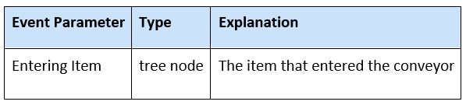
- On Exit:
On Exit occurs whenever an item exits the conveyor.
It has the following parameters:
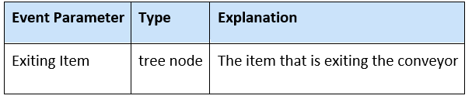
- On Item Bump:
This event occurs when an item or a slug is blocked by another item or slug, forming a single slug.
It has the following parameters:
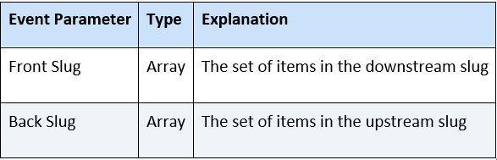
States:
For statistical purposes, the conveyor will be in one of the following states at various points during a simulation run. The current state can be viewed by clicking on the object and then viewing the Statistics pane in Quick Properties.
Empty:
There are no items on the conveyor.
Conveying:
There is at least one item on the conveyor.
Stopped:
There is at least one item on the conveyor, but the conveyor's speed has is set to zero. The conveyor will go into this state immediately when its speed is set to zero (i.e. at the time it STARTS to decelerate to zero).
Blocked:
Only used for non-accumulating conveyors. When an item on a non-accumulating conveyor is stopped or blocked, the conveyor will become blocked. Note again that accumulating conveyors do not use this state. If you want to get better blocked state statistics on accumulating conveyors, you should use photo eyes.
Model 01:
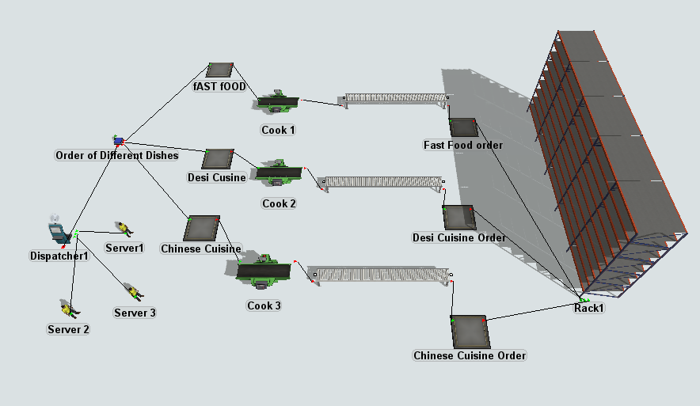
Model 02:
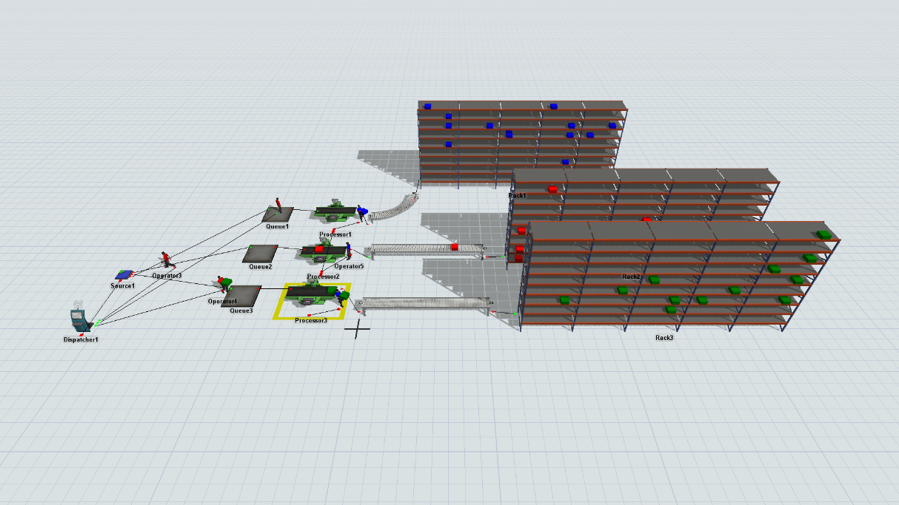
Comments:
In this lab we create a model using conveyors and divide products into three types and learn about how to use conveyors.

Procedure (On students’ own words)
______________________________________________________________________________________________________________________________________________________________________________________________________________________________________________________________________________________________________________________________________________________________________________________________________________________________________________________________________________________________________________________________________________________________________________________________________________________________________________________________________________________________________________________________________________________________________________________________________________________________________________________________________________________________________________________________________________________________________________________________________________________________________________________________________________________________________________________________________________________________________________________________________________________________________________________________________________________________________

Difficulties / Suggestions
______________________________________________________________________________________________________________________________________________________________________________________________________________________________________________________________________________________________________________________________________________________________________________________________________________________________________________________________________________
Concluding Remarks / Comments
____________________________________________________________________________________________________________________________________________________________________________________________________________________________________________________________________________________________________________________________________________________________________________________________________________

Question Answer
- How does a Processor object differ from a Source and a Conveyor in FlexSim?
- What is the role of setup time and process time in the Processor, and how do they affect system throughput?
- How does FlexSim handle multiple flow items being processed simultaneously in a Processor?
- What is the impact of a Processor breakdown on flow items and overall system performance?

Lab Session No.7
To build a model to use the operator and transporters for the material handling and explore the object properties in greater detail
Software:
FlexSim
Theory:
In discrete-event simulation, material handling resources play a critical role in determining system performance, utilization, and throughput. In FlexSim, material handling activities are modeled using task executer objects, primarily Operators and Transporters.
Operator:
Operators can be called by objects to be utilized during setup, processing or repair time. They will stay with the object that called them until they are released. Once released, they can go work with a different object if they are called. They can also be used to carry flow items between objects. Operators can be placed on a network if they need to follow certain paths as they travel.

The operator is a task executer. It implements offset travel depending on whether there's in an involved item for the offset. If there is no item, then it implements the offset exactly like the Task Executer object. It travels so that its x/y center and z base arrives at the destination location. If there is an involved item, then the operator only travels along the x/y plane. It also only travels up to the point where its front edge is at the edge of the flow item, instead of its x/y center. This done by decreasing the total travel distance by (x size(operator) / 2 + x size(item) / 2).
The operator has animations in order to Walk, Walk Loaded, and Stand and more depending on the operator's shape. These animations can be viewed in the Animation Creator by right clicking an operator to open a menu. Point to Edit, then Animations.
Properties:
The operator object has six tabs with various properties. The last five tabs are the standard tabs that are common to all task executers (except the dispatcher). For more information about the properties on those tabs, see:

- The Breaks Tab
- The Collision Tab
- The Triggers Tab
- The Labels Tab
- The General Tab
Only the Operator tab is unique to the operator object. However, most of the properties on this tab are the same as the properties on The Task Executer Tab. Only the first property is unique to the Operator tab.
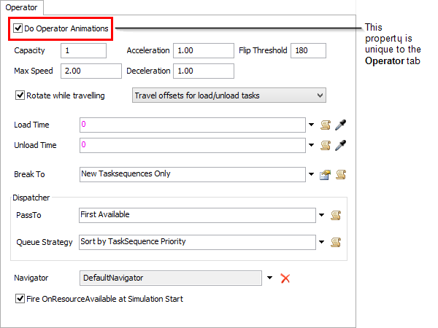

Task Executer (object):
The Task Executer object is a generic task executer. From a certain perspective, you could think of this as being a basic task executer that you can use without having to create all the custom logic the way you would for a Basic TE object. A task Executer has some basic functionality that you can adapt to a variety of uses. This object's default shape is designed to look like an automatic guided vehicle (AGV).
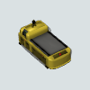

Transporter:
The transporter is used mainly to carry flow items from one object to another. It has a fork lift that will raise to the position of a flow item if it is picking up or dropping off to a rack. It can also carry several flow items at a time if needed.
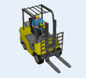
The transporter is a task executer. It implements offset travel in two ways. First, if there is an involved flow item for the travel operation, then it travels so that the front of the fork lift is positioned at the destination x/y location and raises its fork to the z height of the destination location. Second, if there is no involved flow item for the offset travel operation, then it travels so that its x/y center and z base arrive at the destination location.
Properties:
The transporter object has six tabs with various properties. The last five tabs are the standard tabs that are common to all task executers (except the dispatcher).
Only the Transporter tab is unique to the transporter object. However, most of the properties on this tab are the same as the properties on The Task Executer Tab. Only the first two properties are unique to the Transporter tab.
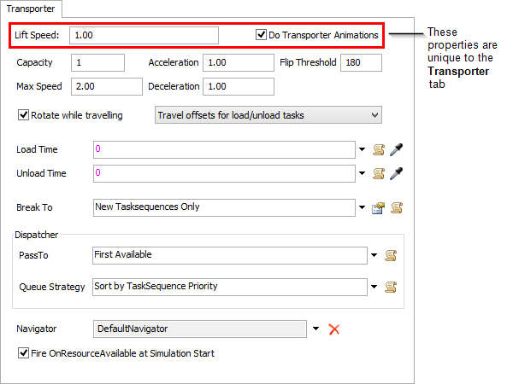

Model:
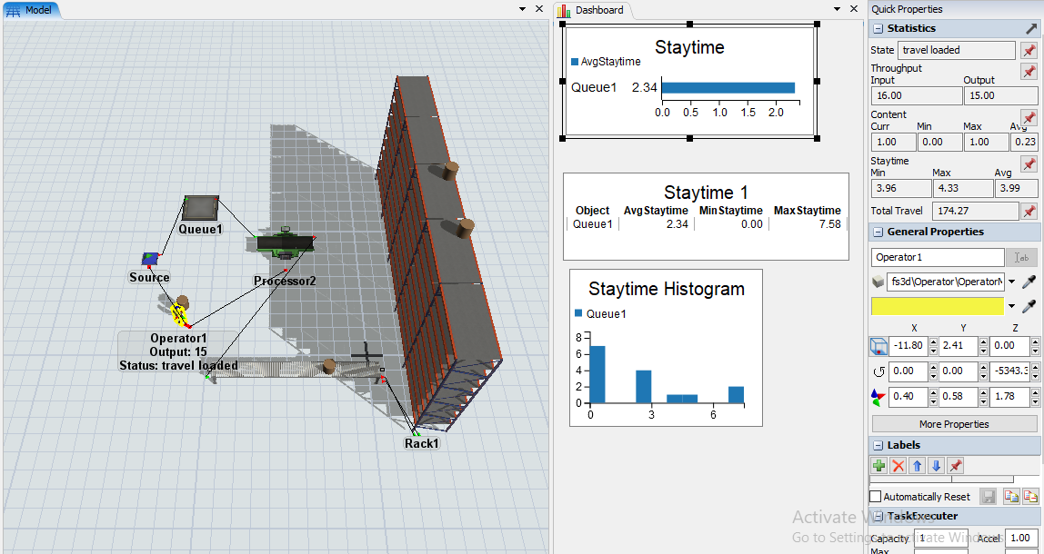
Comments:
In this lab we learn about dashboard and use different charts from dashboard after creating model.

Procedure (On students’ own words)
______________________________________________________________________________________________________________________________________________________________________________________________________________________________________________________________________________________________________________________________________________________________________________________________________________________________________________________________________________________________________________________________________________________________________________________________________________________________________________________________________________________________________________________________________________________________________________________________________________________________________________________________________________________________________________________________________________________________________________________________________________________________________________________________________________________________________________________________________________________________________________________________________________________________________________________________________________________________________

Difficulties / Suggestions
______________________________________________________________________________________________________________________________________________________________________________________________________________________________________________________________________________________________________________________________________________________________________________________________________________________________________________________________________________
Concluding Remarks / Comments
___________________________________________________________________________________________________________________________________________________________________________________________________________________________________________________________________________________________________________________________________________________________________________________________________________
Question:
- How does the Operator’s movement behavior change when it is carrying a flow item compared to when it is not carrying any item?
- What is the functional difference between an Operator and a Transporter, even though both are task executers?
- Why is the Operator tab considered unique, and which type of properties does it mainly control?
- How does assigning Operators or Transporters to a network improve realism and accuracy in material handling models?

Lab Session No. 8
To build a model to combine different in a pellet, through batch and joining.
Software:
FlexSim
Theory:
Combiner:
The combiner is used to group multiple flow items together as they travel through the model. It can either join the flow items together permanently, or it can pack them so that they can be separated at a later point in time. The combiner will first accept a single flow item through input port number 1 before it will accepts the subsequent flow items through the remaining input ports. The user specifies the quantity of subsequent flow items to accept through input ports 2 and higher. Only after all subsequent flow items required by the user have arrived will the setup/process time begin. The combiner can be set to require operators during its setup, processing and repair times.
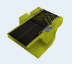
The combiner is a sub-class of the processor, which is in turn a fixed resource. During operation, the combiner first receives exactly one flow item from its first input port. It will wait until a flow item has arrived through input port 1 before it allows other flow items in. Then it collects a batch of flow items using its component list. The component list specifies the number of flow items the combiner should receive from each other input port for each batch. Row 1 of the component list corresponds to the number of flow items that should be received from input port 2. Row 2 corresponds to input port 3, and so forth. The component list is updated automatically when you connect objects to its input ports. If you have the combiner's Properties window open when you add an input port, you will need to close the window and double-click on the combiner again to register the changes.
Once the combiner has collected a batch, it goes through a setup and process time, calling operators to the setup and process operations as defined by the processor functionality. See Processor for more information.
The combiner can operate in one of three modes: pack, join, or batch. In pack mode the combiner moves all flow items that were received through ports 2 and higher into the flow item received through input port 1 and then releases this container flow item. In join mode the combiner destroys all flow items except the one received through input port 1. In batch mode, the combiner simply releases all the flow items once the batch is collected and the setup and process times have finished.
The Pull Strategy field is not used for the combiner. The combiner handles this logic on its own.
If you are transporting flow items into the combiner, then while it is receiving the container flow item, it will only allow one flow item to be in transit to itself at a given time, namely the container flow item. Once the container flow item has arrived, the combiner will allow all other flow items for the components list to be in transit at the same time.
Properties:
The combiner object has seven tabs with various properties. The last four tabs are the standard tabs that are common to all fixed resources.
The first two tabs are available for the processor, combiner, separator, and multiprocessor.
Only the Combiner tab is unique to the combiner object. The properties on this tab will be explained in more detail in the following sections.
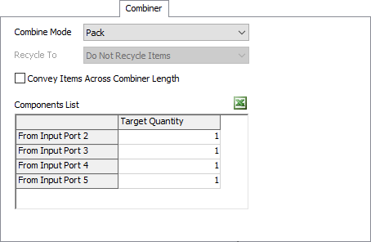
Combine Mode:
Selects the mode that the combiner is operating in.
Recycle to:
This property is only available when Join is selected as the Combine Mode. In join mode, the objects that come in through ports greater than 1 are destroyed after the combiner is finished processing. Rather than destroying the extra flow items, you can use this option to recycle them to a specific flow item recycling bin.
Convey Items Across Combiner Length:
If checked, flow items will travel across the combiner during their process time.
Components List:
This table is used to define how many of each type of flow item the combiner will collect before sending the completed collection downstream. The combiner will use the flow item that arrives through input port one as the container object and will only accept one of them. Each row in the table represents arrivals from input ports numbered two and above. If you make additional connections while this window is open, you will need to close the Properties window and reopen it in order for your changes to register. To update this list dynamically during a model run, use the Update Combiner Component List picklist option in the On Entry trigger.
Target Quantity:
The required number of flow items to be received through the associated input port for each operation.
Model:

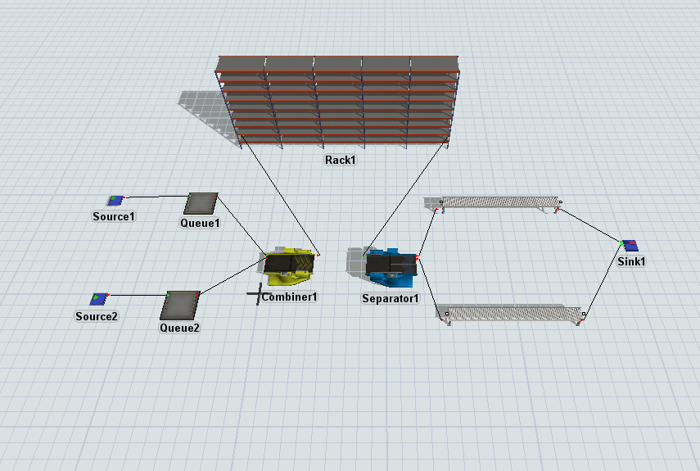
- To build a model to separate parts from the pellet and split a single part into no. of pieces.
Separator:
The separator is used to separate a flow item into multiple parts. This can either be done by unpacking a flow item that has been packed by a combiner or by making multiple copies of the original flow item. The splitting/unpacking is done after the process time has completed. The separator can be set to require operators during its setup, processing and repair times.
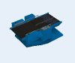
The combiner is a sub-class of the processor, which is in turn a fixed resource. It receives one flow item, then executes the setup and process times for that flow item. If the separator is in unpack mode, then once the setup and process times are finished, the separator moves the unpack quantity out of the flow item and into itself. Then it releases all flow items that it unpacked. Once all unpacked flow items have left the separator, it releases the container flow item. If the separator is in split mode, once the setup and process times are finished, the separator duplicates the flow item so that the resulting total number of flow items is the split quantity. Then it releases all of the flow items. For both unpack and split modes, once all flow items have left the separator, the separator immediately receives the next flow item.
Properties:
The separator object has seven tabs with various properties. The last four tabs are the standard tabs that are common to all fixed resources.
The first two tabs are available for the processor, combiner, separator, and multiprocessor.
Only the Separator tab is unique to the separator object. The properties on this tab will be explained in more detail in the following sections.
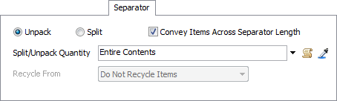
Unpack/Split:
The separator has the following options:
- Unpack:
If this button is checked, the separator will assume that the flow item that entered contains other flow items that need to be removed.
- Split:
If this button is checked, the separator will make duplicate copies of the entering flow item.
Convey Items Across Separator Length:
If checked, flow items will travel across the separator during their process time.
Split/Unpack Quantity:
This picklist returns how many flow items will be unpacked or duplicated by the separator.
Recycle from:
This property is only available in Split mode. In split mode, the flow items that are created can be pulled from recycled flow items rather than creating a new copy. You can use this option to specify what type of flow item should be created.
Model 01:
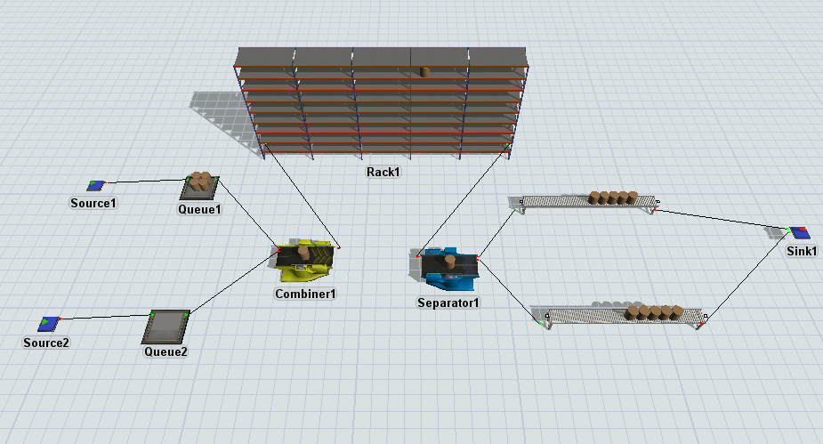
Model 02:
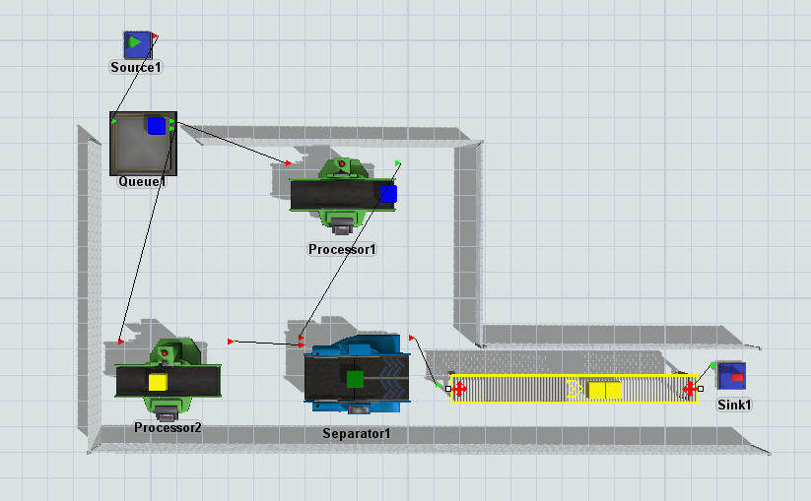
Comments / Procedure:
_________________________________________________________________________________________________________________________________________________________________________________________________________________________________________________________________________________________________________________________________________________________________________________________________________________________________________________________________________________________________________________________________________________________________________________________________________________________________________________________________________________________________________________________________________________________________________________________________________________________________________________________________________________________
Question

Q1. Explain the difference between Pack, Join, and Batch modes of the Combiner. Give one practical example where each mode would be used.

Q2. In a Combiner, the component list shows the following values:
- Port 2 = 2 items
- Port 3 = 3 items
Explain what sequence the Combiner will follow during model execution. What happens if items from Port 3 arrive before the container?

Q3. A Separator is set to Split Mode with a split quantity of 4.
Describe what happens to a single incoming flow item. How is this different from Unpack Mode?

Q4. During the lab, you connected three sources (one container and two component sources) to a Combiner.
Describe the complete flow of items from entering Source 1 to exiting the Sink.

Q5. Identify two problems a student might face when running the Combiner model in FlexSim (for example: no batching, items stuck, component not accepted). Provide a brief solution for each.

Lab Session No. 9
To build a simple tugger train or locomotive movement by using AGV module.
Software:
FlexSim
Objective:
Using FlexSim AGV Module, design and simulate a simple tugger train (locomotive-based AGV system) to transport flow items between multiple fixed resources.
Theory:
Automatic Guided Vehicles(AGVS):
- Using FlexSim's AGV objects, you can study and create the ideal systems for creating an AGV network that maximizes speed and efficiency. FlexSim's AGV module is designed to simulate AGV travel systems at any level of complexity. You can use the AGV module to compare different layouts and dispatching strategies, or to analyze load balancing and capacity constraints. The high-fidelity simulation of AGV travel includes detailed speed, acceleration, and deceleration profiles, as well as accumulation and/or mutual exclusion in travel areas.
- In FlexSim, you can use task executers to transport flow items from one fixed resource to another. The AGV objects use these same basic principles of transportation, but they use more sophisticated travel networks and logic.
- You'll build a system of AGV networks that will transport medical supplies, laundry, and waste to and from the loading dock to the rest of the hospital.
- When you're finished, your 3D model will look and function similar to the following image:


AGVs Using Standard 3D Logic:
In this task, you'll learn how to create a basic AGV network using only standard 3D logic. You'll learn how to create AGV paths and connect 3D objects to control points along those paths. You'll also learn how to add more than one AGV to a simulation model.
AGVs Using Process Flow:
In this task, you'll learn how to set up the AGV process flow template. You'll also learn how to create pick up areas, drop off areas, and park points. At the end of the tutorial, you'll learn how to adjust control point sensitivity in order to make your system more efficient.
Using Elevators with AGVs:
In this task, you'll learn how to use elevators to transport AGVs to multiple floors in a model. You'll also learn how to create custom flow items and how to send AGVs to different types of locations based on the type of load it is carrying.
Custom AGV Settings:
In the task, you'll learn how to create custom loading and unloading times for different types of flow items. You'll learn how to use a global table to create custom loading and unloading times for each type of custom flow item.
Model:
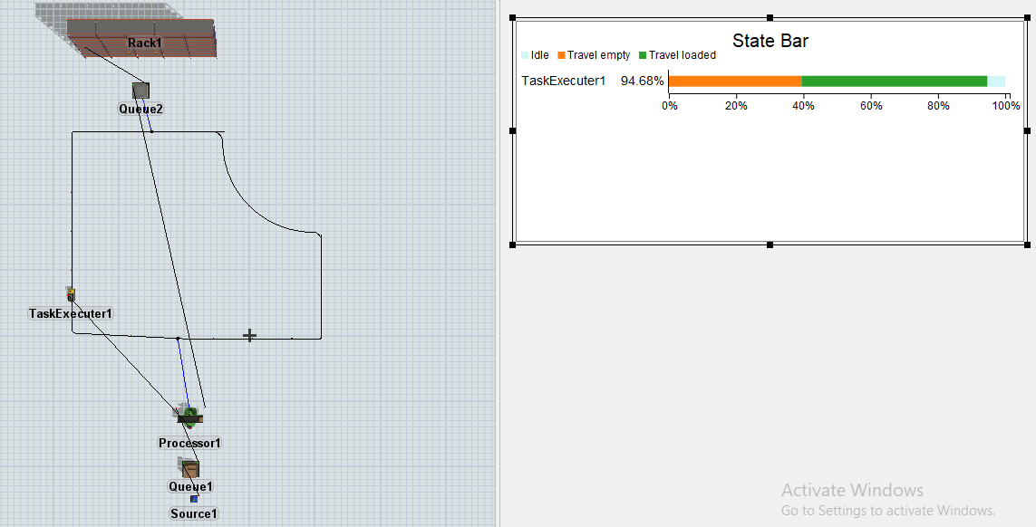
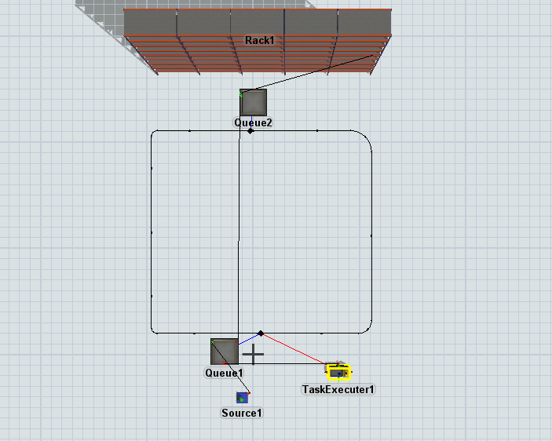

Task Description:
You are required to build and analyze a tugger train–based AGV system that transports materials between a loading station, two processing stations, and a drop-off station.
Your model must include the following:
- AGV / Tugger Train Configuration
  - Create a tugger train or task executer.
  - Define a closed-loop AGV path network manually.
  - Ensure proper path connectivity and direction.
  - Assign at least one tugger with multiple carts.
- Pickup and Drop-off Logic
  - Define pickup and drop-off control points along the AGV path.
  - Connect fixed resources (source, processors, sink) to control points.
  - Ensure correct loading and unloading behavior.
- AGV Travel and Logic
  - Implement AGV movement using:
    - Either Standard 3D Logic or
    - AGV Process Flow
  - Set appropriate speed, acceleration, and deceleration parameters.
  - Ensure no collisions or deadlocks occur on the path.
- System Analysis
  - Run the simulation for a defined time period.
  - Observe and analyze:
    - AGV utilization
    - Waiting time at pickup/drop-off points
    - Throughput of transported items
Comments:
In this lab, we create a model using tugger train or task executer if we use tugger train we have to define the path for this.

Comments / Procedure:
_________________________________________________________________________________________________________________________________________________________________________________________________________________________________________________________________________________________________________________________________________________________________________________________________________________________________________________________________________________________________________________________________________________________________________________________________________________________________________________________________________________________________________________________________________________________________________________________________________________________________________________________________________________________
_________________________________________________________________________________________________________________________________________________________________________________________________________________________________________________________________________________________________________________________________________________________________________________________________________________________________________________________________________________________________________________________________________________________________________________________________________________________________________________________________________________________________________________________________________________________________________________________________________________________________________________________________________________________
Short analysis:
_______________________________________________________________________________________________________________________________________________________________________________________________________________________________________________________________________________________________________________________________________________________________________________________________________________________________________________________________________________________________________________________________________________________________________________________________________________________________________________________________________________________________________________________________________________________________________________________________________________________________________________________________________________________________________________________________________________________________________________________________________________________________________________________________________________________________________________________________________________________________________________________________________________________________________________________________________________________________________________________________________________________________________________________________________________________________________________________________________________________________________________________________________________________________________________________________________________________________________________________________________________________________________________________________________________________________________________________________________________________________________________________________________________________________________________________________________________________________________________________________________________________________________________________________________________________________________________________________________________________________________________________________________________________________________________________________________________________________________________________________________________________________________________________________________________________________________________________________________________________________________________________________________________________________________________________________________________________________________________________________________________________________________________________________________________________________________________________________________________________________________

Question and Answer
- Explain why defining an optimized AGV path is critical in a tugger train system.
- Compare the use of Standard 3D Logic versus Process Flow for AGV control.
- Identify one bottleneck in your model and suggest one improvement to enhance system efficiency.
- How would increasing the number of carts or adding a second tugger affect system performance?

Lab Session No.10
To build a model for diversion of parts to different conveyors depending upon their different colors (Types).
Software:
FlexSim (2025 or compatible version)

Lab Objective
The objective of this lab is to develop a simulation model in FlexSim that diverts parts to different conveyors based on their assigned colors. Students will learn how to:
- Connect conveyors using different methods in FlexSim
- Use Decision Points for attribute-based routing
- Implement color-based logic for part diversion
- Visualize material flow in an automated material handling system
Theory:
Connecting Conveyors:
When you create a connection between a conveyor and another object, you make it possible for these objects to interact together. The most common way that objects interact in FlexSim is to transfer items from one object to another or send messages to another object.
The process for connecting conveyors is relatively similar to the process you would use to connect any other object from the FlexSim Library. However, there are a few differences to be aware of. The following sections will discuss some of the different methods for connecting conveyor objects.
Connecting Two Conveyors:
Conveyors will automatically snap together if they are close enough. To snap two conveyors together:
- Click on one conveyor and drag it close to the edge of the other conveyor. When the edges of the two conveyors get close enough, they will snap together.
- After you release the mouse button, a transfer will appear that connects the two conveyors together. The transfer will look like a small square box that overlaps the edges of the two conveyors:
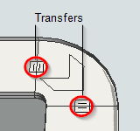

Using the Join Conveyors Object:
Even though the Join Conveyors object is in the FlexSim library, it actually functions more like a tool than a 3D object. You can use the Join Conveyors tool to connect two conveyors with a curved conveyor:
- In the FlexSim the Conveyors group, click on the join conveyors object. You will then enter into conveyor joining mode. When you are in conveyor joining mode, your mouse pointer will change to a plus sign with a Join Conveyors icon next to it.
- Once in joining mode, click on the center of the first conveyor you'd like to join. After clicking on the conveyor, you'll notice that a yellow line will follow your mouse as it moves, similar to the line that appears when you are connecting two FlexSim objects.
- Click on the second conveyor you'd like to join. You'll then notice a new curved conveyor will appear between the two conveyors. Two transfer points will also appear on both ends of the new conveyor.
- When a connection is created between a conveyor and another object, FlexSim enables interaction between them. The most common interaction is the transfer of items (flowitems) from one object to another. Conveyors can also send messages or signals to connected objects.
- Connecting conveyors is similar to connecting other FlexSim objects; however, conveyors have specialized snapping and joining behaviors to ensure smooth material flow

Model 01:

Method 1: Connecting Two Conveyors by Snapping
Conveyors will automatically snap together if they are placed close enough.
Steps:
- Click on the first conveyor and drag it close to the edge of the second conveyor.
- When the edges are sufficiently close, the conveyors will snap together automatically.
- Release the mouse button.
- A transfer object (small square box) will appear at the joint, indicating a valid connection.
This transfer ensures seamless movement of items from one conveyor to the next.

Basic Conveyor Layout
Description:
- A source generates parts of different colors (e.g., red, blue, green).
- Parts move along a main conveyor.
- No diversion logic is applied in this model.
Purpose: To understand basic conveyor connections and material flow.

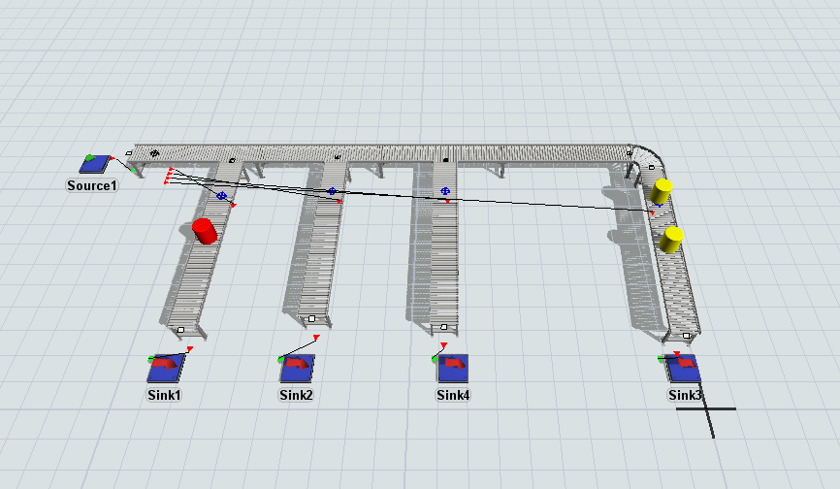
Model 02:

Method 2: Using the Join Conveyors Tool
The Join Conveyors object acts as a tool rather than a traditional 3D object. It is used to connect conveyors with a curved or angled section.
Steps:
- From the Conveyors group in the FlexSim Library, select Join Conveyors.
- You will enter conveyor-joining mode (cursor changes to a plus sign with a Join Conveyors icon).
- Click at the center of the first conveyor.
- Move the mouse toward the second conveyor; a yellow guide line will appear.
- Click the center of the second conveyor.
- A curved conveyor will be automatically created between the two conveyors.
- Transfer points will appear at both ends of the curved conveyor.
This method is useful when conveyors are not aligned linearly.

Color-Based Diversion Model
Description:
- A Decision Point is placed on the main conveyor.
- Multiple output conveyors are connected after the decision point.
- Each output conveyor corresponds to a specific color.
Logic:
- The Decision Point evaluates the color attribute of each flowitem.
- Based on the color, the part is routed to the corresponding conveyor.
Example Routing Rule:
- Red parts → Conveyor 1
- Blue parts → Conveyor 2
- Green parts → Conveyor 3
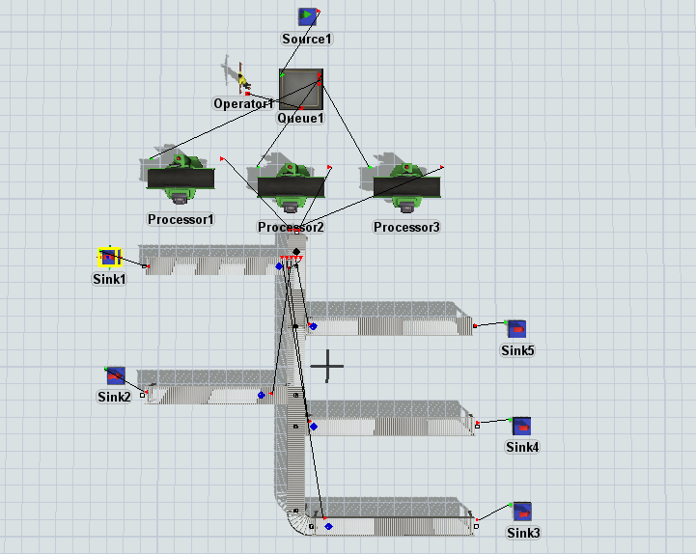

Implementation Steps (Suggested)
- Insert a Source object and configure it to generate items of different colors.
- Add a Straight Conveyor and connect it to the source.
- Place a Decision Point on the conveyor.
- Add multiple conveyors after the decision point.
- Use snapping or the Join Conveyors tool to connect all conveyors properly.
- Open the Decision Point properties.
- Define routing logic based on item color.
- Run the simulation and observe part diversion.

Results and Observations
- Parts are successfully diverted based on their assigned colors.
- Smooth transfer between conveyors confirms correct connections.
- Decision Point logic ensures correct routing without collisions or delays.

Comments / Procedure:
__________________________________________________________________________________________________________________________________________________________________________________________________________________________________________________________________________________________________________________________________________________________________________________________________________________________________________________________________________________________________________________________________________________________________________________________________________________________________________________________________________________________________________________________________________________________________________________________________________________________________________________________________________________________________________________________________________________________________________________________________________________________________________________________________________________________________________________________________________________________________________________________________________________________________________________________________________________________________________________________________________________________________________________________________________________________________________________________________________________________________________________________________________________________________________________________________________________________________________________________________________________________________________________________________________________________________________________
Short analysis:
_______________________________________________________________________________________________________________________________________________________________________________________________________________________________________________________________________________________________________________________________________________________________________________________________________________________________________________________________________________________________________________________________________________________________________________________________________________________________________________________________________________________________________________________________________________________________________________________________________________________________________________________________________________________________________________________________________________________________________________________________________________________________________________________________________________________________________________________________________________________________________________________________________________________________________________________________________________________________________________________________________________________________________________________________________________________________________________________________________________________________________________________________________________________________________________________________________________________________________________________________________________________________________________________________________________________________________________________________________________________________________________________________________________________________________________________________________________________________________________________________________________________________________________________________________________________________________________________________________________________________________________________________________________________________________________________________________________________________________________________________________________________________________________________________________________________________________________________________________________________________________________________________________________________________________________________________________________________________________________________________________________________________________________________________________________________________________________________________________________________________________

Question
- Why are Decision Points important in automated conveyor systems?
- How can attributes other than color be used for diversion?
- What industrial applications use color-based or attribute-based sorting?

Lab Session No. 11
To build a model with the fluid objects and analyze how they interact with each other and how to include them in a model with discrete objects.
Software:
FlexSim
Theory:
Fluid Generator:
The Fluid Generator provides an infinite supply of fluid material for a model. The Generator can be set to refill at a fixed rate (that can be faster or slower than the outgoing rate) or it can refill itself a set amount of time after it becomes empty.
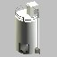
Fluid Tank:
The Fluid Tank is a simple Fluid Object that can receive and send material at the same time. The modeler decides the maximum capacity of the Tank and up to three points (called "marks") that will cause triggers to fire when the content in the Tank reaches them.
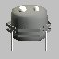
Fluid Mixer:
The Fluid Mixer is used to combine products together into a single, new product. The different materials can either be pulled sequentially or in parallel. The Mixer always works in batches. It does not send any material until it has received and processed all the material that it was set to receive.
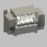
Fluid Pipe:
The Pipe is used to simulate the time required to move material from one object to another. It can appear as either a cylindrical pipe, or as a simple conveyor.
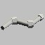
Item to Fluid:
The Item to Fluid is an object that is used to interface between the fluid objects and the discrete objects. It receives flow items and converts them to fluid material.
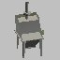
Fluid Processor:
The Fluid Processor is used to simulate a processing step that continuously receives and sends fluid material (such as a continuous cooker).
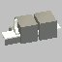
The Fluid Processor receives and sends material based on an over-all rate that the modeler specifies. The modeler specifies the maximum output rate of the Processor. This value is used to determine the input rate as well. The actual output rate is based on the rate that material came in. Material will leave at the same rate that it entered, unless the output is, for some reason, lowered (such as the downstream object closing its input ports or breaking down). If this happens, the material will "back up" in the Processor and more will be available to send when the downstream object can receive more again. Once the downstream object has received all of the "backed up" material, the output rate will go back to the input rate. The amount of time that material spends in the Processor is based on the Processor's maximum output rate and its maximum capacity.
Model 01: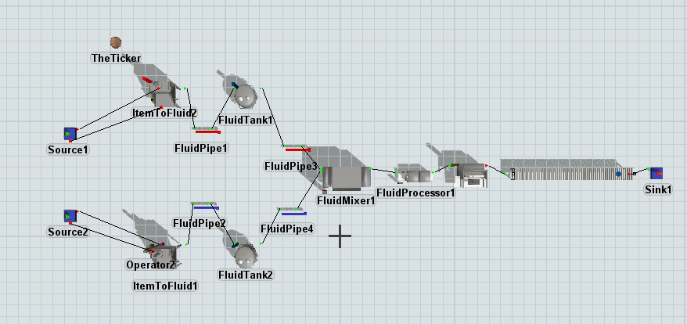
Model 02:
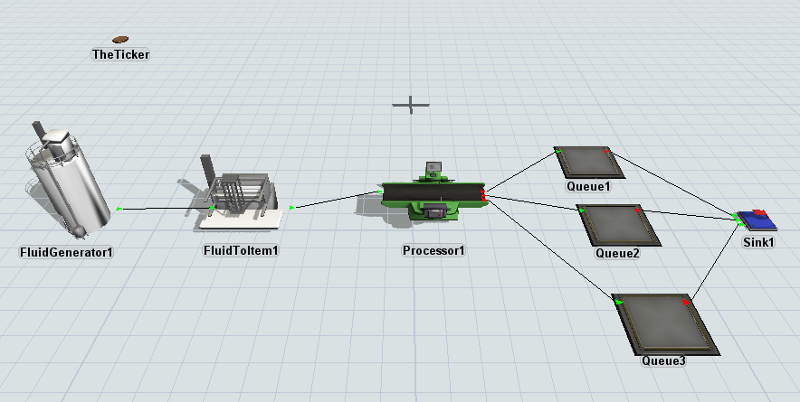
Comments:
In this lab, we create a model in which a fluid convert into objects.

Procedure (On students’ own words)
______________________________________________________________________________________________________________________________________________________________________________________________________________________________________________________________________________________________________________________________________________________________________________________________________________________________________________________________________________________________________________________________________________________________________________________________________________________________________________________________________________________________________________________________________________________________________________________________________________________________________________________________________________________________________________________________________________________________________________________________________________________________________________________________________________________________________________________________________________________________________________________________________________________________________________________________________________________________________

Difficulties / Suggestions
______________________________________________________________________________________________________________________________________________________________________________________________________________________________________________________________________________________________________________________________________________________________________________________________________________________________________________________________________________
Concluding Remarks / Comments
________________________________________________________________________________________________________________________________________________________________________________________________________________________________________________________________________________________________________________________________________________________________________________________________
Questions
- What is the main function of a Fluid Generator, and how can its refill rate affect a simulation?
- How does a Fluid Tank use “marks” to trigger events in a model, and why is this useful for controlling fluid flow?
- Explain how a Fluid Mixer combines multiple fluids and why it always processes materials in batches.
- How can fluid objects be integrated with discrete objects in a FlexSim model, and what are some challenges in doing so?

Lab Session No. 12
To build a model in which one operator works on more than one machines.
Software:
FlexSim
Theory:
- We have one operator that runs three processors. We need this operator to move efficiently back and forth between them, processing several items at one processor before moving over to the next.
- We’ll begin by creating our model in FlexSim. We will need a source, which will produce the items in our system; two queue objects, where items will queue before they enter the processors; three processor objects, which the operator will use to process the items; one operator; and a sink, which will allow our items to leave the system.
- The last step is to connect our objects. Objects can be connected in one of two ways: by clicking the Connect Objects button on the toolbar, left-clicking with the mouse to connect the objects, and then pressing the Escape key to leave connection mode; or by holding the “A” key and left-clicking to connect. Using your preferred method, start with the source and connect each item downstream toward the sink, except for the operator. We will also need one center port connection, a reference connection that can be made by holding the “S” key or by choosing Connect Center Ports by clicking the arrow next to the Connect Objects button. Choose your preferred method and make center port connections between the operator and each of the processors.
- Now that our model is ready, we need to adjust a few parameters to replicate the conditions we’re discussing. Double-click on the first processor to bring up its properties window. We want the operator involved in processing our items, so check the Use Operator for Process box. Click OK to save and close the window.
- Next, double-click on the second processor, check the Use Operator for Process box as we did before, but this time click the drop-down menu next to Preemption and select “preempt only”. The default option, “no preempt,” means the processor will not be preempting any activities. By choosing “preempt only” for the second processor, we’re allowing it to preempt the first processor, completing its tasks before allowing the operator to resume other duties; this will become important later. Click OK to save and close.
- Next, double-click on the third processor, check the Use Operator for Process box as we did before, but this time click the drop-down menu next to Preemption and select “preempt only”. The default option, “no preempt,” means the processor will not be preempting any activities. By choosing “preempt only” for the third processor, we’re allowing it to preempt the second processor, completing its tasks before allowing the operator to resume other duties; this will become important later. Click OK to save and close.
- Finally, we need to set up batching sizes for our queues. Double-click the first queue to open its properties window. Check the box next to Perform Batching and type in “5” for the Target Batch Size. This will force the queue to batch five items before sending them through to the next processor. Then check the box next to “Flush contents between batches.” This will force the entire batch to leave the queue, or flush, before any new items can be brought in. Open the properties window of the second queue and enter in the exact same parameters.
- Let’s click reset and run the model. Boxes will be created by the source and will start to enter the first queue. Once five items are in the queue, the operator will walk over and help to process the items; each processed item will move on to the next queue, which begins to batch its own group of five items. Once this is done, the operator will move to the other processor and process the same five items a second time before they leave the system through the sink. Note that even if the first queue batches another five items before the operator finishes at the second processor, he won’t leave his post until the current batch is finished. This is because we set the second processor to preempt other activities.
Model:
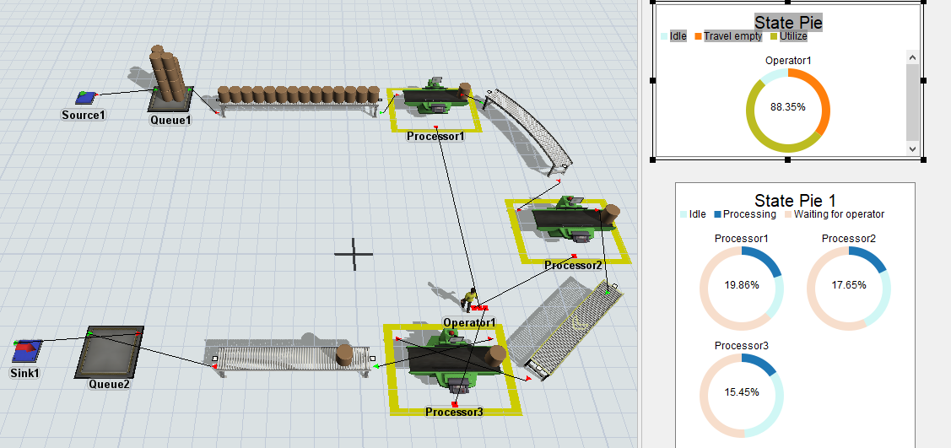

Comments:
In this lab, we use one operator that works on more than one operator and create a model using conveyors and processors.

Procedure (On students’ own words)
______________________________________________________________________________________________________________________________________________________________________________________________________________________________________________________________________________________________________________________________________________________________________________________________________________________________________________________________________________________________________________________________________________________________________________________________________________________________________________________________________________________________________________________________________________________________________________________________________________________________________________________________________________________________________________________________________________________________________________________________________________________________________________________________________________________________________________________________________________________________________________________________________________________________________________________________________________________________________

Difficulties / Suggestions
______________________________________________________________________________________________________________________________________________________________________________________________________________________________________________________________________________________________________________________________________________________________________________________________________________________________________________________________________________
Concluding Remarks / Comments
________________________________________________________________________________________________________________________________________________________________________________________________________________________________________________________________________________________________________________________________________________________________________________________________
Questions
- How does the “Use Operator for Process” option affect the operation of a processor in FlexSim?
- What is the purpose of preemption, and how does selecting “preempt only” for a processor influence operator assignment?
- Explain the difference between standard object connections and center port connections when linking the operator to multiple processors.
- How does an operator manage tasks across multiple processors efficiently, and what factors in the model affect this behavior?

